TASK - 2
Sensor Based Simulation

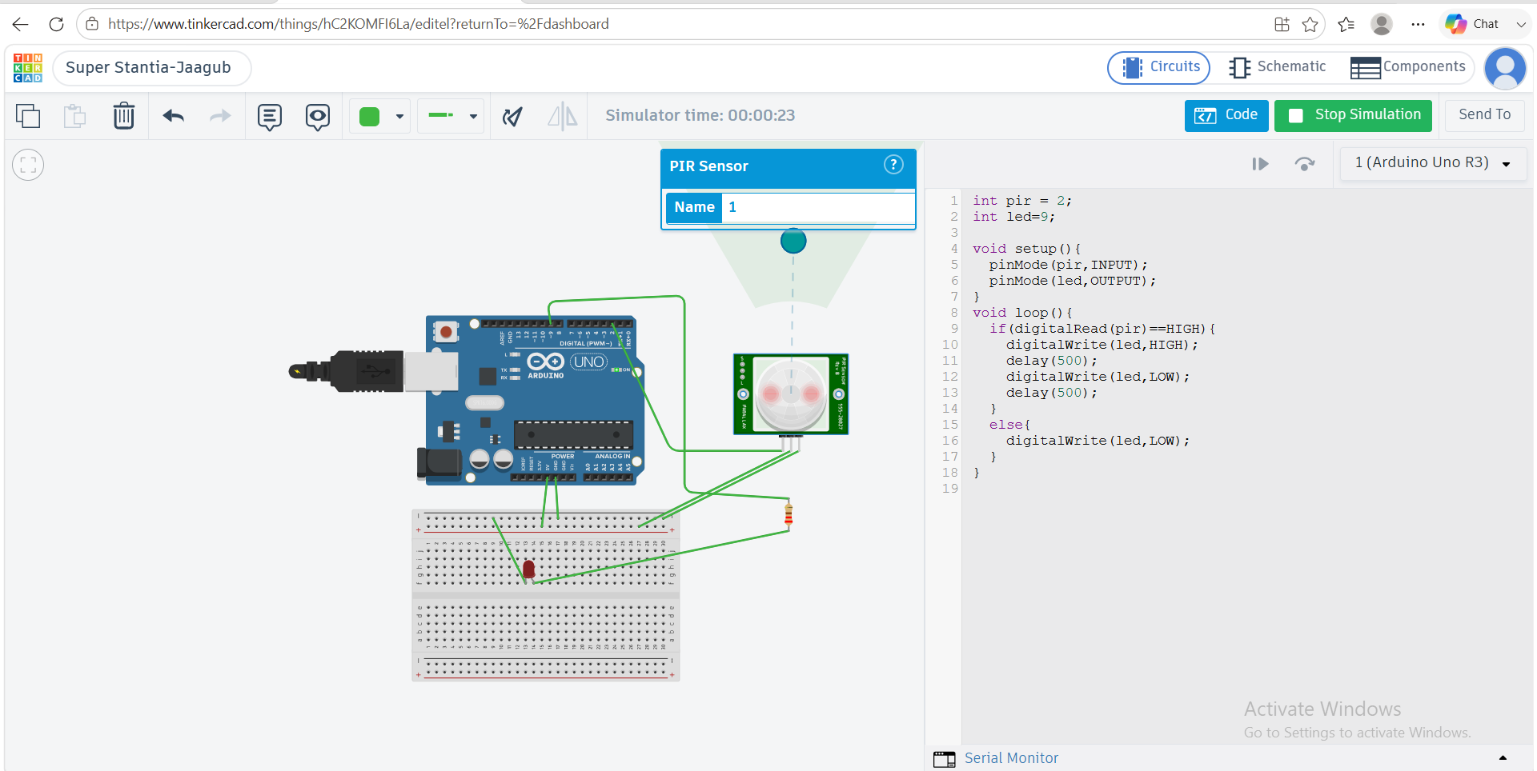
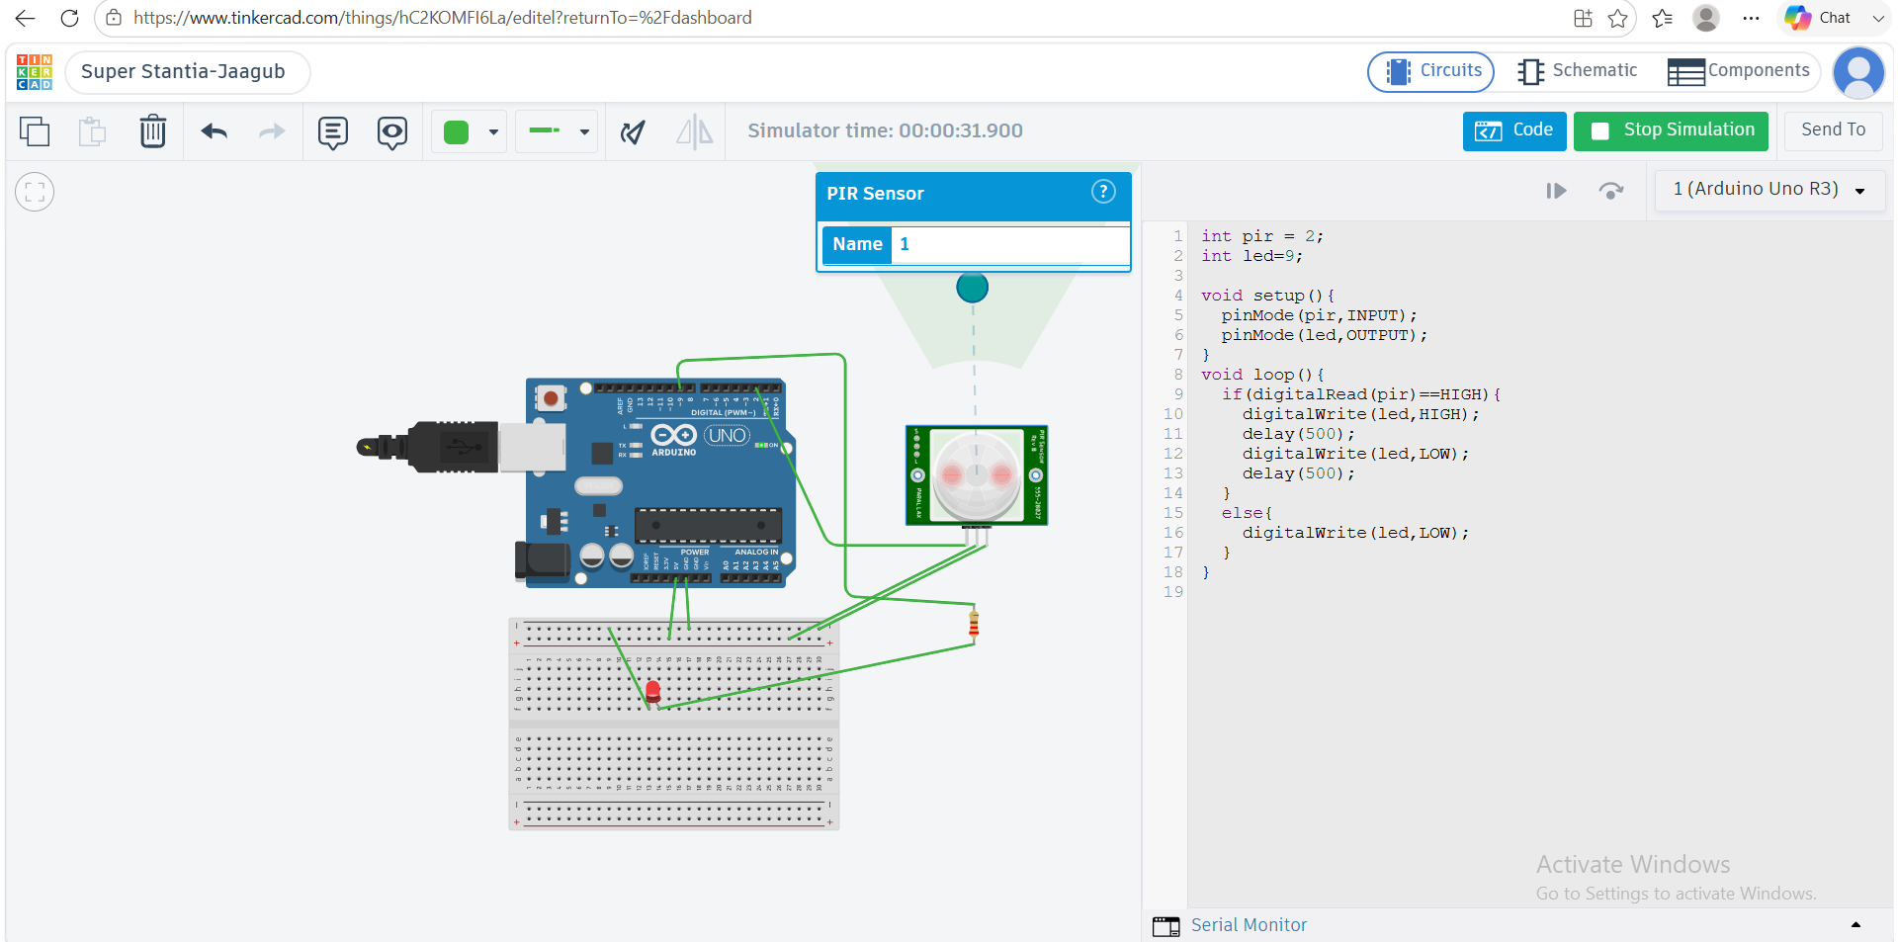
Fig: Simulation

1.Code
int pir = 2;
int led=9;

void setup(){
pinMode(pir,INPUT);
pinMode(led,OUTPUT);
}
void loop(){
if(digitalRead(pir)==HIGH){
digitalWrite(led,HIGH);
delay(500);
digitalWrite(led,LOW);
delay(500);
}
else{
digitalWrite(led,LOW);
}
}

2.Explanation
- int pir = 2;
The PIR sensor is connected to pin 2.
- int led = 9;
The LED is connected to pin 9.
- pinMode(pir, INPUT);
Sets the PIR sensor as an input.
- pinMode(led, OUTPUT);
Sets the LED as an output.
- digitalRead(pir)
Checks whether the PIR sensor detects motion.
- If motion is detected, the sensor gives a HIGH signal.
- digitalWrite(led,HIGH);
Turns the LED ON.
delay(500);
Waits for 0.5 seconds.
8.digitalWrite(led,LOW);
Turns the LED OFF.
9.If there is no motion, the LED stays OFF.

3.Working
1.The PIR sensor sends a signal to the Arduino through pin 2.
- The Arduino checks the signal from the PIR sensor.
3If motion is detected, the signal is HIGH.
4.The Arduino then turns the LED ON.
5.The LED stays ON for 0.5 seconds.
6.After that, the Arduino turns the LED OFF for 0.5 seconds.
7.This ON and OFF process continues while motion is detected.
8.If there is no motion, the signal is LOW and the LED remains OFF.

